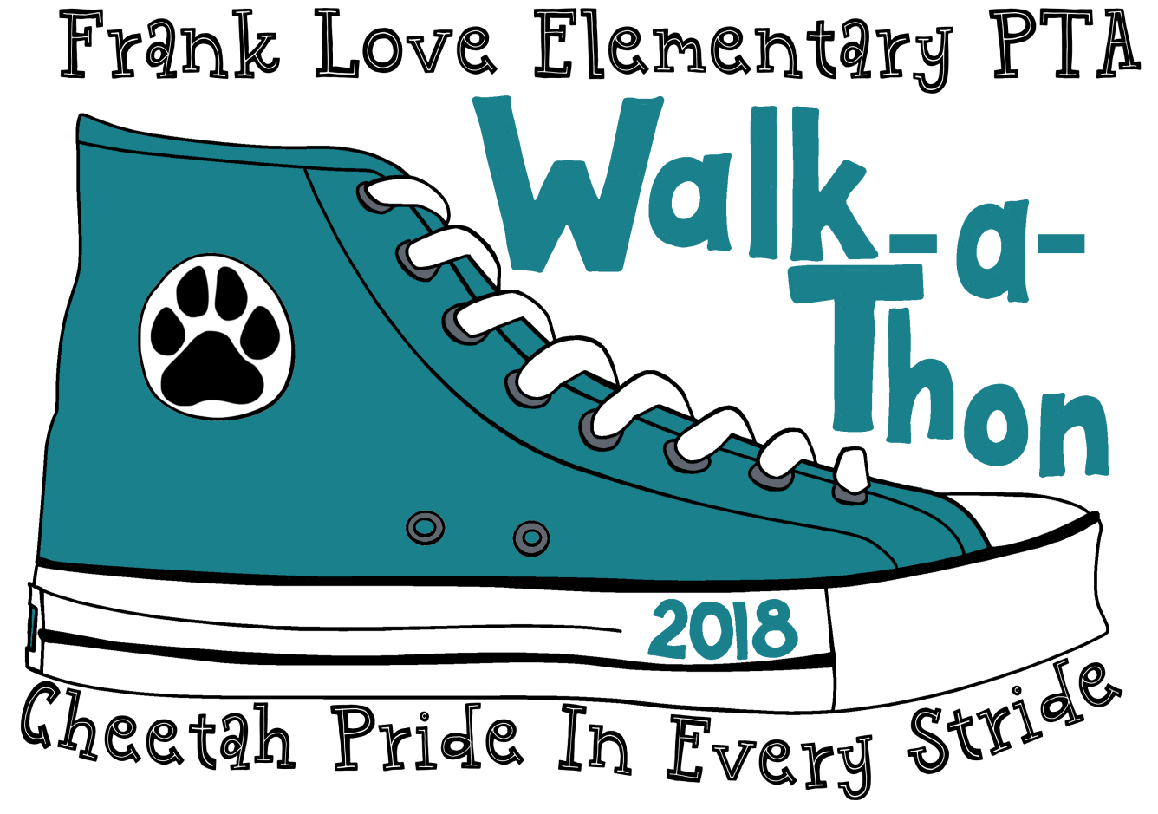

Pledges are due

Monday, Sept 25th

in order to be entered

into Grand Prize drawings.

Friday, Sept. 28th

BBQ 5:00-6:30 PM Walk 6:30-7:30 PM

* Collect a minimum of $40 in pledges, per student, to earn one paw print beanie.
* $5 for one turkey dog, veggie burger, or burger & one soda or water & a bag of chips.
* Teachers scooping ice cream!
* Ice cream: $3 non PTA members, $1 PTA members
* Memberships $15 for one adult and $25 for 2 adults.
* Wear your FLE Cheetah Spirit Wear, or purchase at event.
* Glow product will be available for sale.
* Sports and clubs community tents.
* Race your parents --remind them to wear their running shoes!
* Report your lap count to earn a keychain charm!
* Weekly drawings of Menchies gift cards from pledges turned in early.
* Two Grand Prizes of $100 Amazon gift cards.

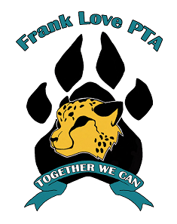

All children are welcome. We make accommodations so that children of all abilities have access to our events.

Please contact our event coordinator at shannonuflepta@gmail.com to request accommodations or support.

*These activities are not sponsored nor endorsed by the Northshore School District or any of its schools. The district assumes no responsibility for the conduct during or safety of the activities. Northshore School District shall be held harmless from any cause of action, claim, or petition filed in any court or administrative tribunal arising out of the distribution of these materials including attorney's fees and judgments or awards.*