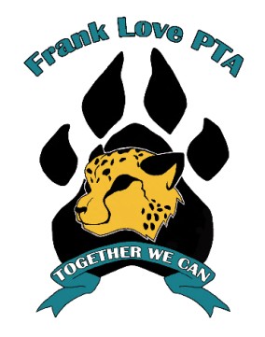
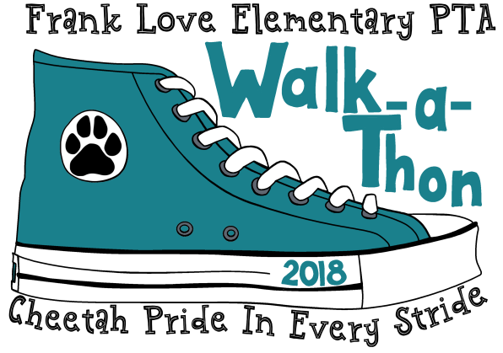
FRANK LOVE ELEMENTARY
2018 WALKATHON
SEPTEMBER 28, 2018, 5 pm

Student (First, Last) Name Teacher

Your generous donation is tax deductible and will help Frank Love PTA fund many important school and student enrichment programs.
Each student who collects $40 minimum in donations will receive one paw print beanie,
to be delivered to your child's classroom in the weeks following the walk.
There will be weekly prize drawings for pledges turned in early. Two grand prizes will be drawn from all donations returned by Sept 25th.

Please return this envelope with your Pledge Money to school by Monday, September 25, 2018
Donate online at www.flepta.weebly.com. Please make checks payable to: FRANK LOVE PTA.

Sponsor’s Name | Email | Donation  Amount | Cash / Check
 |  | Total

These activities are not sponsored nor endorsed by the Northshore School District or any of its schools. The district assumes no responsibility for the conduct during or safety of the activities. Northshore School District shall be held harmless from any cause of action, claim, or petition filed in any court or administrative tribunal arising out of the distribution of these materials including attorney's fees and judgments or awards.

